BACKGROUND

How green should the city be? See if you can prove that a green environment is good for people.

Health
Do trees in the city make for healthier residents? That thought is obvious. But hard evidence for it is lacking. Out and about in the jungle of green research.

NRC
Marcel aan de Brugh
15 May 2024

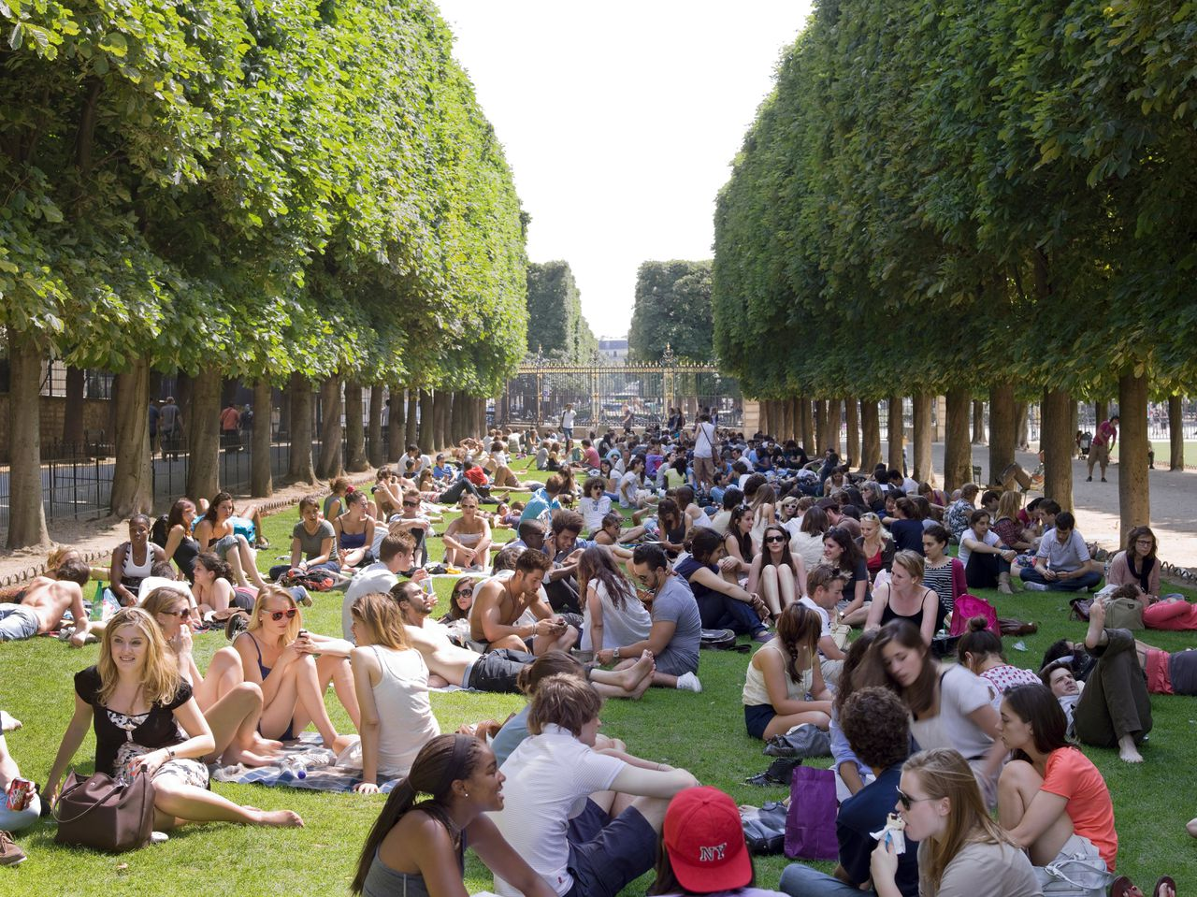
Jardin du Luxembourg in Paris. Photo Janine Schrijver

Fifteen hundred randomly selected residents of the Bulgarian city of Plovdiv filled in a questionnaire last month. Whether they ever visit any of the city's parks? How often? Whether they ever stroll along the Maritsa river, which runs through Plovdiv? How they experience it? And much more. Within the year, they complete the list twice more. And in between, researchers measure participants' blood pressure, BMI and heart rate several times, and take blood samples to determine all sorts of substances associated with stress, cardiovascular disease, the immune system.

The research in Plovdiv is part of a European project started last year, designed to, as the website describes, "gather more evidence" showing how nature can promote human health and well-being.

But why more evidence? Hasn't it been obvious for a long time that a green environment is good for people? "For many people, this is obvious," says Mathew White, environmental psychologist at the University of Vienna and co-ordinator of the European study. He says there is also a lot that points in that direction. "But scientifically it is not yet so easy to prove that watertight."

And even if much research points to a favourable effect, many questions remain, says Sjerp de Vries, sociologist at Wageningen University & Research. HOW exactly does a green environment promote health? "The underlying mechanism is not yet known," he says. And you can generally say that green is good. "But planners and policymakers want it to be more specific." Many cities are greening, but space is limited. So, how do you best lay out a park where people can not only recreate and play sports, but also unwind? Does one big park work better than several small ones? Should all streets be greener? Do water features belong? De Vries: "There is still a lack of knowledge there too."

Less anxiety and depression
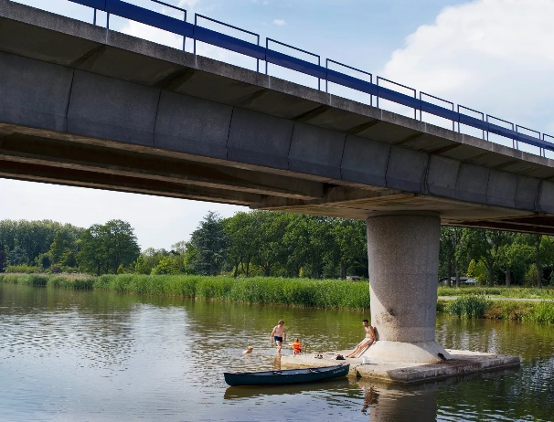
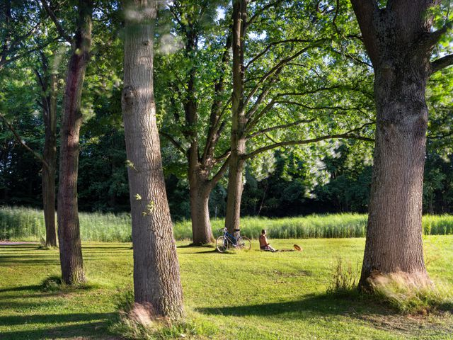
Until a decade ago, most studies investigating the effect of a green environment on health were cross-sectional in design. This combined data on people's health and their environment. All sorts of things have been studied in this way. People living in a greener environment were found to have, on average, a higher life expectancy. They have fewer cardiovascular diseases. Less depression, anxiety disorders, ADHD, dementia. Babies have higher birth weights on average. "But with this type of research you demonstrate a relationship, not a causal relationship," says De Vries, who wrote an overview of the state of all research in this field two years ago, as a chapter in the book The symbiotic city. In cross-sectional research, you cannot be 100 per cent sure whether people are healthier precisely because of that greener environment, he says. "People who live in greener environments tend to be wealthier and live healthier lives anyway," he says. It is true, though, says De Vries, that by far the majority of cross-sectional studies arrive at a positive relationship. Although there are also studies that find no clear, or a negative relationship. "But certainly the latter are rare."
The Zuiderpark in Rotterdam.
Photos: Janine Schrijver

To make a found association between greenery and health stronger, researchers correct for all kinds of factors. De Vries: "You then rule out, for example, that the difference in health found has to do with income, education, age." But there are so many factors that can influence this. "You are never sure if you have overlooked a factor," he says.

That is why a group of researchers (including De Vries) argued for more variation in research in a now widely cited publication in Environmental Research in 2017. "Instead of a cross-sectional design, studies should, if at all possible, use a longitudinal, interventional or experimental design," they write. By now, there are many of these, says Matilda van den Bosch, physician and senior researcher at ISGlobal, a research institute in Barcelona that focuses on global health.

We saw more versatile play behaviour on the green playgrounds and the girls moved more
Jolanda Maas - Free University

Longitudinal research involves following a group of people through time. At the beginning of a study, the degree of greenery in their environment is determined, as well as their health. If something changes in the environment - they move, for example - this is taken into account. Van den Bosch points to a 2019 review article in Lancet Planetary Health, on which colleagues from her institute collaborated. They analysed nine longitudinal studies in which over eight million people in seven countries had participated. In seven studies, mortality decreased as the environment became greener. Two studies did not find that association.

"The advantage of longitudinal studies," says Mathew White, coordinator of the aforementioned European study, "is that you are not comparing person A with person B, as in cross-sectional research, where all kinds of cultural differences complicate the study. But you are comparing person A to himself." White herself is working on a longitudinal study that tracks 2.3 million residents over the age of 16 in Wales. The results for the first period, 2008-2019, were published last year. These show, among other things, that for every 10 percentage point increase in green cover, in a 300-metre perimeter, the risk of depression or anxiety disorder decreases by 20 per cent.

Nevertheless, De Vries also keeps a lid on this type of research. "Even in this case, you cannot be sure whether improved health is purely attributable to more greenery," he says.

Greening schoolyards
Then there is the intervention study. Associate professor Jolanda Maas, affiliated with the clinical psychology section of the Free University in Amsterdam, conducted such a study at nine primary schools. At five the schoolyard was greened, at four nothing changed - tiles and stones dominated. Children in grades 4, 5 and 6 were followed. "We saw more versatile play behaviour in the green playgrounds and the girls moved more," says Maas. As a creative task, the children had to invent things you can do with a brick. "In the green squares, they came up with more of them," says Maas. And after a break, the children were more concentrated. In many other settings, such a study design is also interesting, she says. For instance, does therapy outside have additional advantages over therapy inside? This is what Maas will investigate, with eighteen mental health institutions.

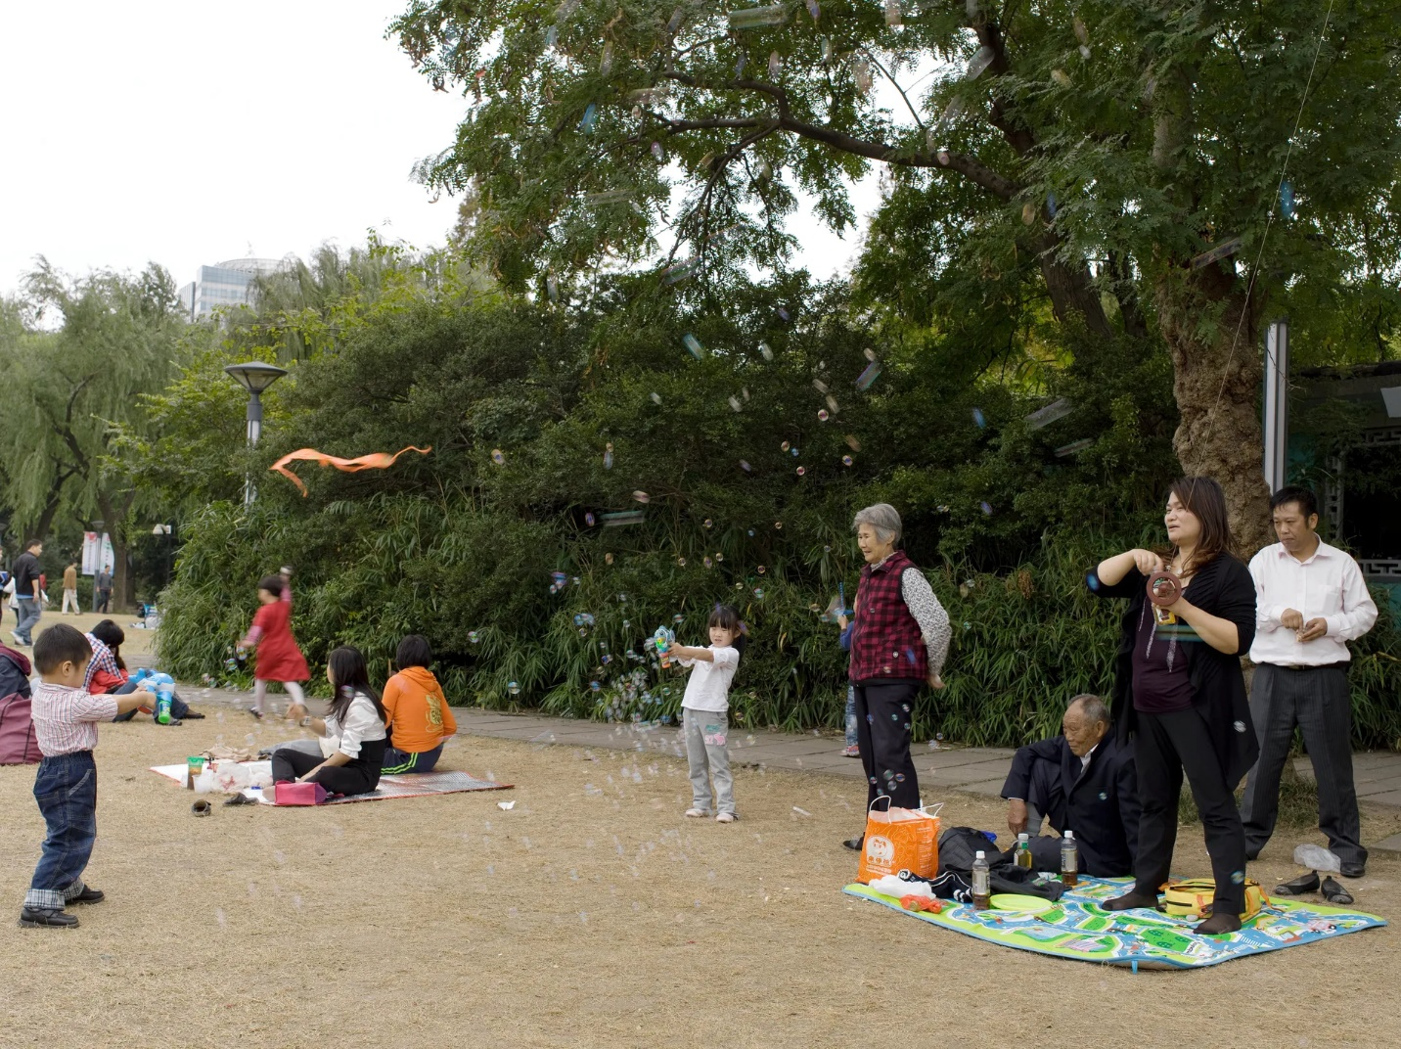
Zhongshan park in Shanghai. Photo Janine Schrijver

And then there is experimental research. In this, subjects are often shown pictures or videos of different landscapes in a laboratory: forests, mountains, skyscrapers. The effects on mood, stress and concentration ability, among other things, are then measured. But such research generally lasts only a few hours, says De Vries. "You don't know whether the effects you see last longer," he says. And that is what you do want, a structural effect.

For Van den Bosch and Maas, there is no doubt that green is good for health. "Of course it could be better researched, but let's not sit still because of that," says Maas. De Vries is more cautious. According to him, the link between a green environment and health is "at least partly causal". Mathew White now thinks the evidence for that causal link is "pretty strong". But he stresses that nature is "not a silver bullet". It has to be part of a broader urban infrastructure that promotes health. "For example, also limit car traffic and give more space to cycling and walking. And pay attention to loneliness and work-related stress."

With more greenery in the city, people sleep better at night
Matilda van den Bosch - physician and senior researcher

But then the next step. If greenery is good for health, how does that work? One idea was that trees and shrubs filter pollution from the air. But that effect appears to be minimal, say Maas, De Vries and White alike. Another idea is that people will exercise more if there are more parks and ponds nearby. De Vries writes in his book chapter two years ago that that relationship is "weak", and causality "questionable". Van den Bosch also says the evidence is "inconsistent". But she is keen to stress that many studies show a positive association.

However, very clearly demonstrated, says Van den Bosch, is the reduction of the heat island effect in cities. Due to a lot of stone and concrete, they retain a lot of heat and are many degrees warmer than their surroundings. The summer 2023 heat wave in Europe caused over 60,000 premature deaths. With more trees, there is "extra shade and cooling", says Van den Bosch. "And with more greenery in the city, people sleep better at night." Colleagues at ISGlobal saw premature deaths decrease by 20 per cent when leaf cover in neighbourhoods increased from 15 to 30 per cent. The study, among 100 European cities, appeared in The Lancet last year.

In particular, poorer neighbourhoods, which are often the least green, benefit most from additional green space, Van den Bosch and Mathew White stress.

White thinks that the biggest effect of greenery, "is probably through the mental route". It reduces stress, improves mood and concentration. "And mental health, in turn, is intertwined with physiology." For example, stress affects cardiovascular disease. But far from everything has been researched, he adds. "For instance, people care about feeling rooted somewhere, having a sense of place. As a psychologist, I am interested in this. Very little research in green spaces has looked at this so far."

There is a new line of research, though, says Van den Bosch, looking at the microbiome in the human gut. Does it change as you live in a greener environment, and does that affect health? She refers to a Finnish review article published last month showing that ingesting soil microorganisms is beneficial for the immune system.

Different types of greenery
Van den Bosch hopes that the European project launched last year will answer many questions. Within it, she herself is coordinating a study that will run from September in Barcelona, Padua and Salzburg. People take a 40-minute walk with rest and mindfulness exercises in between. In Barcelona, there are walks along the beach, in a park, or through a more stony environment. Participants' measurements include heart rate and blood pressure. And cheek swabs are taken, to measure all kinds of biomarkers. Van den Bosch: "We want to investigate whether such walks can also be used as therapy."

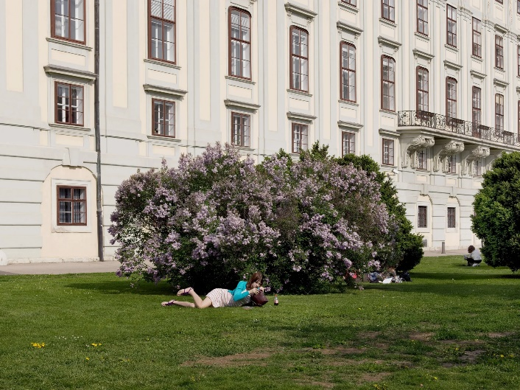
Another big unanswered question is: what type of green space has the most impact? Parks? Green verges? Very little research has explicitly compared different types of green space, researchers (including Sjerp de Vries) concluded in a review article published last year in People and Nature, which included 215 studies.
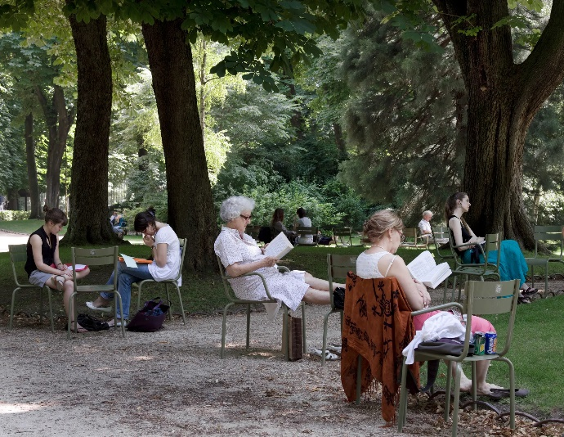
Jardin du Luxembourg in Paris. The Heldenplatz in Vienna.
Photos: Janine Schrijver

Maas points to the 3-30-300 rule, drawn up three years ago by Cecil Konijnendijk, professor of urban forestry at the University of British Columbia. The rule states that people should have views of at least three trees from their homes, that the crowns of trees cover at least 30 per cent of a neighbourhood, and that every resident should be able to visit a park or 'green space' within 300 metres.

"But this is more of a rule of thumb, not hard science," says Maas. She finds the rule "very tree-oriented". But Matilda van den Bosch thinks it is actually a good starting point. "What we need is more trees," she says. "I put my vote on trees."

All in all, De Vries calls it a difficult puzzle. To conserve greenery around cities, more high-rise buildings are coming up within existing city limits. But will people still have their own gardens? Wageningen research published last year (in which De Vries collaborated) shows that of the 21 diseases and disorders studied, nine occur less in people who have their own gardens. These include stroke, cancer, heart disease and intestinal infections. De Vries stresses that it was a cross-sectional study, so he speaks of an association, not a causal relationship.

Biodiversity
And it gets even more complex. Urban green space should not only be good for health, but preferably also for biodiversity. It should also dampen the effects of climate change, such as the heat island effect.

At the same time, extra greenery can also introduce more problems. Trees and grasses give off pollen and can cause hay fever. Greenery can introduce pesky insects, such as ticks. Parks are also associated with more crime - robberies, drug dealing. But Van den Bosch doubts there is a causal link. There are also studies, she says, that show green spaces actually reduce crime. "Overall, I think it is a very dangerous message to point out the negative effects of greenery. Our existence and survival depends on greenery and on healthy ecosystems."

Maas acknowledges that much is still unclear. At the same time, she wonders if all the questions are ever going to be answered. "But, is that even necessary?" she asks. "We know that more green is better anyway."

